

**AMERICAN INTERNATIONAL UNIVERSITY – BANGLADESH (AIUB)**

**Faculty of Engineering**

**Bachelor of Science in Electrical and Electronic Engineering**

**Renewable Energy Technology lab performance test**

|  |  |  |
| --- | --- | --- |
| **Spring 2020-21** | **Total Marks: 20** | **Time: 1 hr 30 mins** |

The government will install the biggest solar power plant of the country at the haor areas of Sunamganj to provide electricity to about 900 families. The plant will be set up at Sulla upazila of the north-eastern district. Bangladesh Power Development Board (BPDB) inked a deal last week with Rahimafrooz Renewable Energy Ltd to construct the plant and associated distribution line at a cost of Tk 30.5 crore. The plant is expected to generate 500 kW load per day, sufficient to meet a significant portion of the electricity demand of Aguai village of Habibpur union parishad in Sunamganj. The system will consist of **ABCD** panels of 280 watts. A six-kilometer distribution line will be built to provide electricity connection to the area. The plant's per unit production cost is expected to be Tk 45, but customers will pay Tk 8-10 depending on the amount they will consume as the government will provide subsidies on it. Rahimafrooz will maintain the first-year operation of the plant, with BPDB to take over from then. The plant is expected to last about 25-30 years.

Now design the above-mentioned solar power plant using RETscreen software. Paste the screenshot of your solution in the appropriate spaces provided below (there are in total 6 screenshots). If any parameters are not given, then assume a suitable value based on lab experiment number 5 and mention the values in your answer.

*This is an individual task

*Here **A = 3rd digit of your ID, B = 4th digit of your ID, C = 5th digit of your ID and D = 6th digit of your ID**. For example, If ID = **18-78253-2**, then number of panels will be **7825.**

*Convert the word file into PDF and rename the file with your **ID only.**

*Upload the file in team’s assignment section

* **50%** of total marks will deducted in case of delayed submission

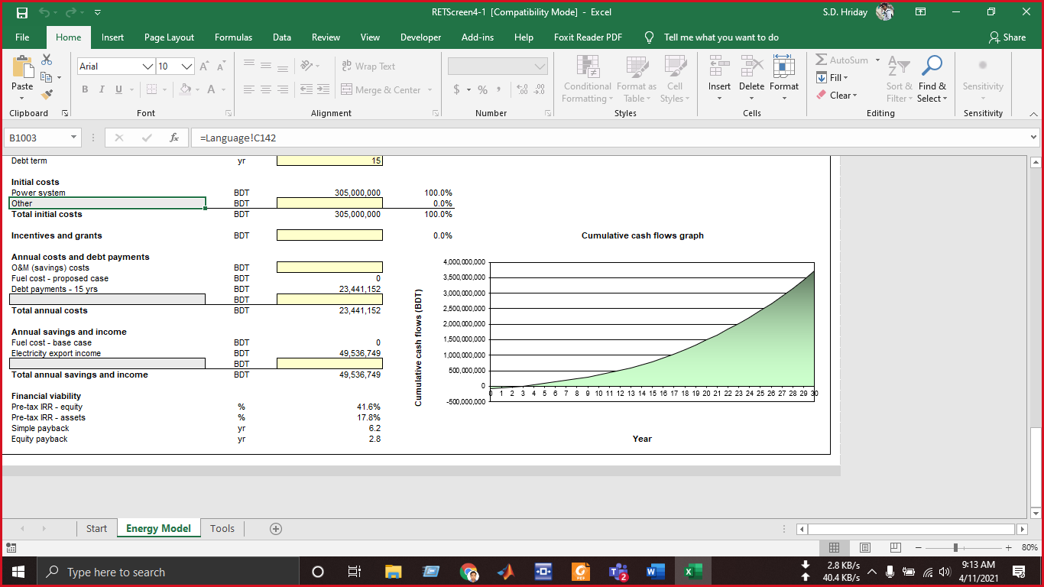**Progress after 50 mins (paste screenshot of your progress after 50 mins is gone):**

1. **Project information: (use your name and ID while giving the information)**

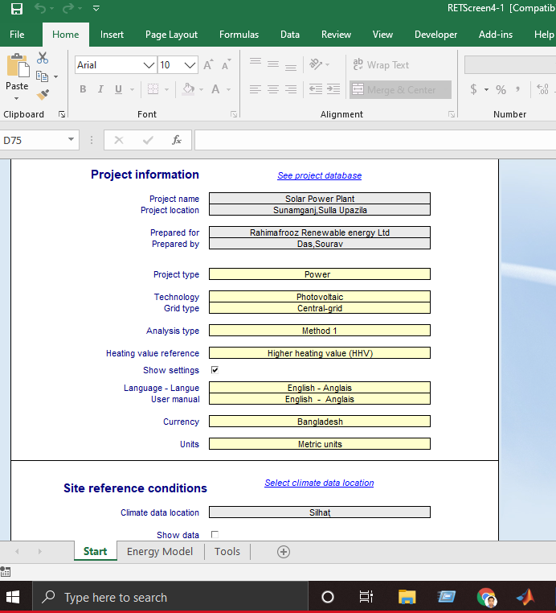

1. **Climate data:**

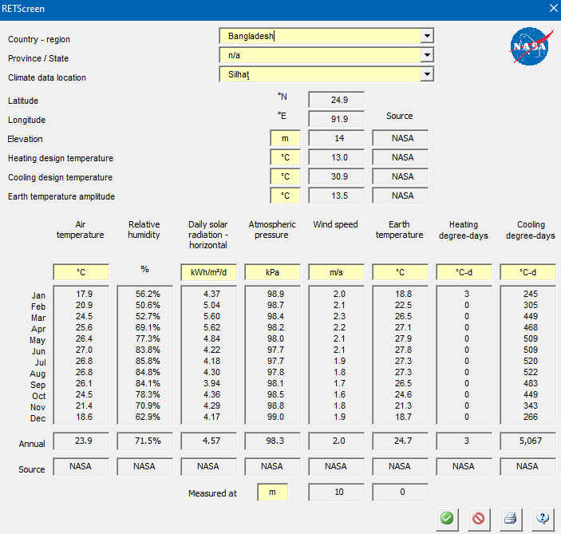

1. **Proposed power system:**

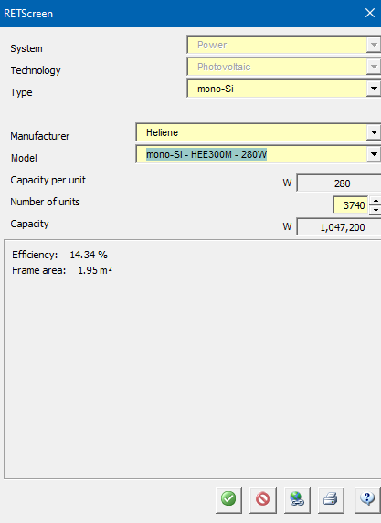

1. **Emission analysis:**

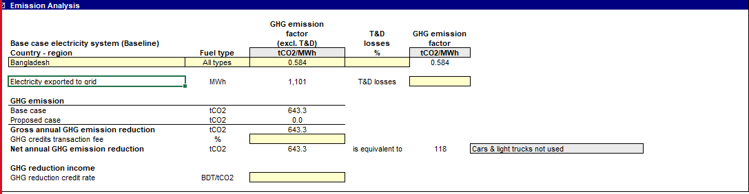

1. **Financial analysis:**

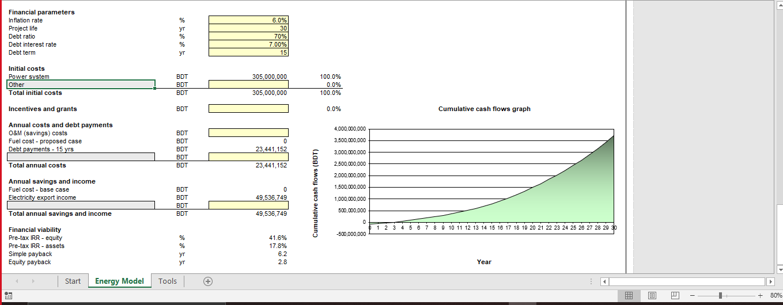

1. **Cumulative cash flow graph:**

